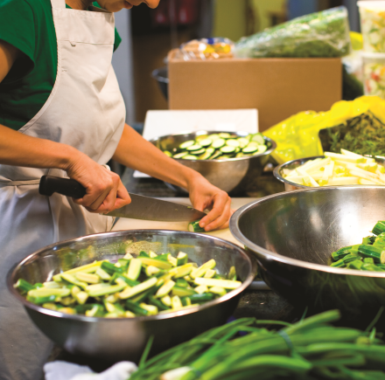
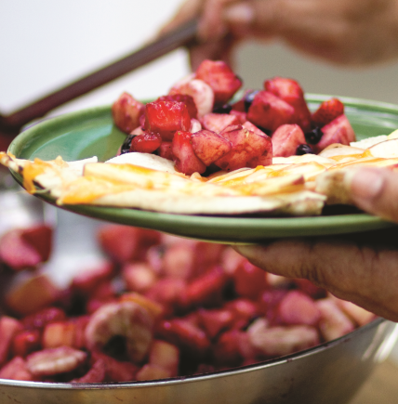
START 2018 OFF
ON THE RIGHT FOOT!
Permanent residents and New comers are welcome to register!!
It’s FREE, and includes free childminding!!

Every Monday, starts January 29th from 9:30am to 1:00pm

♥ improve your basic cooking skills and learn new recipes!
♥ join in a 30-minute group walk each week!
♥ share healthy meals with new friends and work as a team!
♥ make a 12 week commitment to learn how you can become a healthier you!

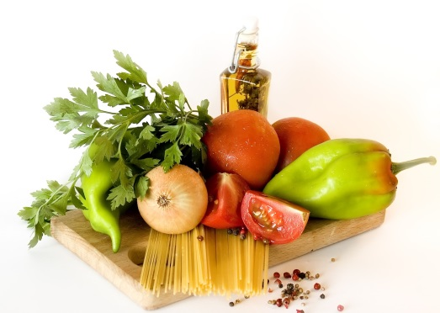

2131 Renfrew Street at 5th Avenue
Register with Eva Aboud
604 251 1225 ext. 238
eva@froghollow.bc.ca

