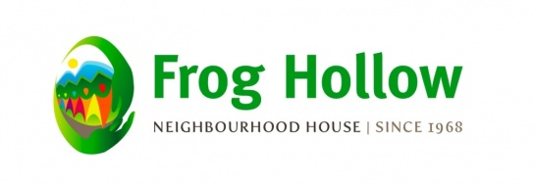

Harvest Festival
Thursday, August 31st 2017 10am to 2pm
Located at Clinton Park- Grant and Slocan St.

Lots to See and Do!
Watermelon, Picnic, Bubbles, Dance, Sing along, Carnival Band, Tai Chi
Seed Give Away, Fire Department, Hastings Sunrise Community Policing Centre Bike Registration, Farmers Market, Hastings Sunrise Community Food Network, Seasons of Food,
Hastings Learning Garden, Bake Sale Fundraiser for Seniors Programs

And the Famous

If it RAINS we will have the Event at Frog Hollow Neighbourhood House 2131 Renfrew St at 5th ave

Enter your Proudest Vegetable You Have Grown
Win a PRIZE!!
Contest Announcements Begins at Noon
Last call for veggie entry is at 11:45 am

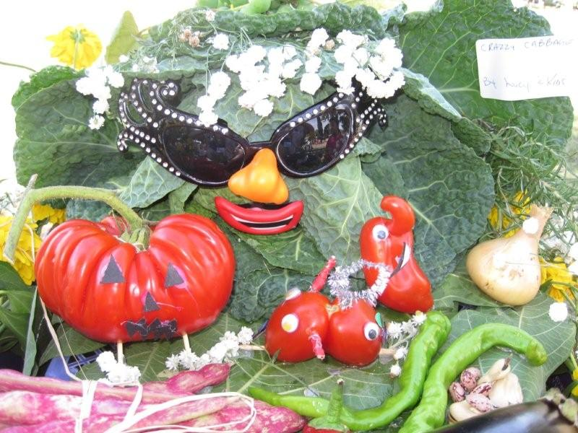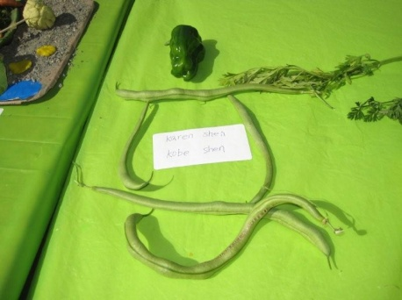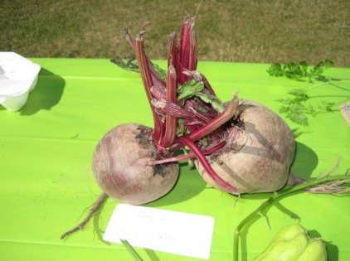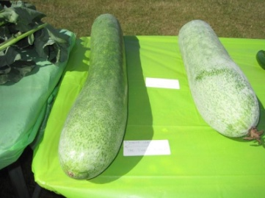

Contact: Eva Aboud (604) 251 1225 ext 238 eva@froghollow.bc.ca

