Nobodys Perfect Parenting Program

Starts Tuesday February 7 to March 7, 2017

(5 sessions)
6:00 to 8:15 pm

This program is free,

with a free children’s program for children 18 months to 5 years

When you attend the Nobody’s Perfect Program you will learn about:
- Child development-helping children grow
- Community services
- First aid
- Positive parenting tips
- Other topics for parents

You will receive a certificate after completing the course

For more information and to register, please call Lea at 604-251-1225.
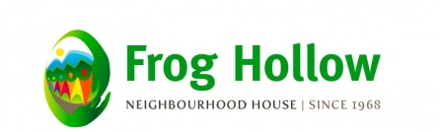
2131 Renfrew Street, Vancouver BC

