Welcome to join our FREE 16 week Empowering Program!

Community Connections

Pathways to Leadership Program

For Newcomers and Immigrant Women with

Permanent Resident Status
The Pathways to Leadership Program will provide food, free childminding, bus tickets and:
- Work with you to explore your interests, skills, and strengths
- Help you build a career plan for work that fits your life and goals
- Learn to advocate for yourself and your community
- Explore opportunities to volunteer and build your Canadian experience
- Build your network and connect with other people, programs, and organizations for ongoing learning
- Give you information on employment, education, and training resources in the Vancouver area
First 8 weeks of the Leadership Programs Begins Tuesdays, October 17th to December 12^{th 2017}
^{9:15am -12:00pm}
Continues…
Tuesdays, January 16th to March 6^{th 2018}
^{9:15am -12:00pm}

Learn More!
Welcome to our Information Session available October 10th
9:30 am to 11:30 am

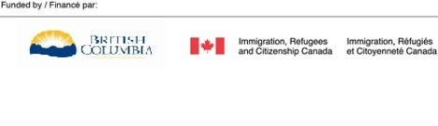
2131 Renfrew Street, Vancouver
To register contact Eva Aboud at 604 251 1225 ext. 238
eva@froghollow.bc.ca
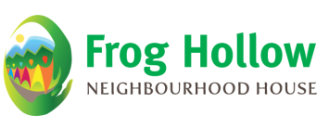
Child minding and Bus tickets available!

