Community Walk

**社區健步行**

[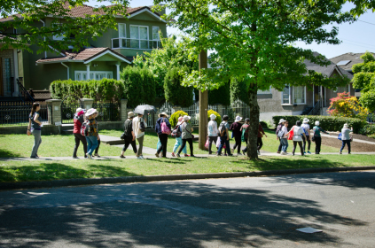](https://communityconnection.wordpress.com/2016/05/07/frog-hollow-neighbourhood-walk-photos-recap/dsc_3621edits/) [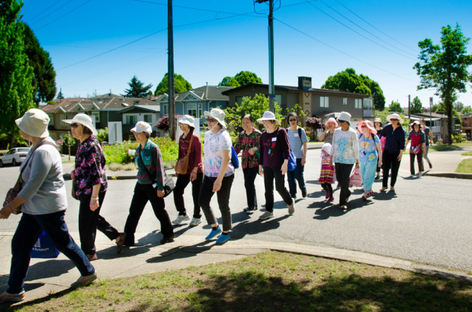](https://communityconnection.wordpress.com/2016/05/07/frog-hollow-neighbourhood-walk-photos-recap/dsc_3626edits/) 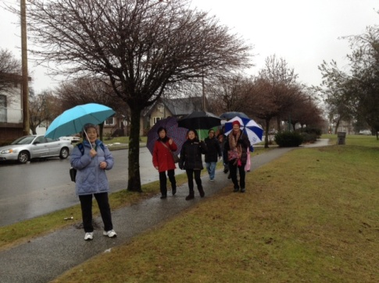

Date: (Wed) Sept11, 25, Oct 9, 23, Nov 6, 20, Dec 4, 18, every second week

Time: 10:00am start at Frog Hollow NH,

Return around 11:30 am

*Meet new friends and enjoy exploring the community

(三) 9月11, 25日, 10月9, 23日, 11月6, 20日12月4日

十時在青蛙鄰舍中心出發, 大約十一時三十分回程

*藉此機會認識新朋友, 與及欣賞美麗的社區

For more information and registration報名:

Please call Manda at 604 251 1225 or [manda@froghollow.bc.ca](mailto:manda@froghollow.bc.ca)

2131 Renfrew St, Vancouver  